Laws of the Game – Modified

**12 and Under (U11/U12)**

Law 1 – The Field of Play

**SMALL-SIDED FIELD**

Dimensions: The field of play must be rectangular. The length of the touchline must be greater than the length of the goal line.

Length: minimum 70 yards maximum 90 yards

Width: minimum 45 yards maximum 55 yards

Field Markings: Distinctive lines not more than (5) inches wide. The field of play is divided into two halves by a halfway line. The center mark is indicated at the midpoint of the halfway line. A circle with a radius of eight (8) yards is marked around it.

The Goal Area: 6 yards out from the goal line x 6 yards wide of each goalpost.

The Penalty Area: 14 yards out from the goal line x 14 yards wide of each goalpost. Within each penalty area a penalty mark is made ten (10) yards from the midpoint between the goalposts and equidistant to them. An arc of a circle with a radius of eight (8) yards from each penalty mark is drawn outside the penalty area.

Flagposts: Conform to the FIFA Laws of the Game.

The Corner Arc: Conform to the FIFA Laws of the Game.

Goals: Goals must be placed on the center of each goal line. They consist of two upright posts equidistant from the corners and joined at the top by a horizontal crossbar. The recommended distance between the posts is eighteen (18) feet and the distance from the lower edge of the crossbar to the ground is six (6) feet.

Optional: A 7’ x 21’ goal is allowed.

Safety: Goals must be anchored securely to the ground. Portable goals may only be used if they satisfy this requirement.

11U Option: Build-out lines may be used as outlined in the 10U rule modifications, but the field should otherwise meet 12U standards.

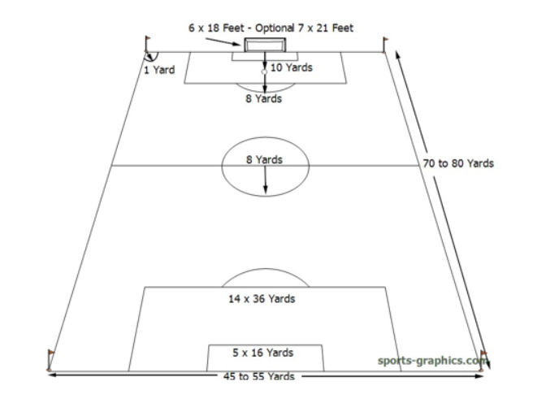

Law 2 – The Ball

Size four (4). The ball will need to be FIFA Quality.

Optional: use a lightweight size four (4) ball (see note below).

A lightweight version reduces the weight of a size 4 soccer ball while staying within the standards set by U. S. Soccer. Physical benefits of a lightweight ball include less stress on joints at the moment of impact, less impact from heading and young players can make long passes, hard shots and block attempts by opponents.

Law 3 – The Number of Players

A match is played by two teams, each consisting of not more than nine (9) players, one of whom is the designated goalkeeper. A match may not start or continue if either team consists of fewer than six players.

Substitutions: At any stoppage of play and unlimited.

N. B.: A player who is suspected to have a head injury leaves the field of play for additional evaluation, a substitution can be made in that moment.

Playing time: To develop players need to play, so it is recommended that each player plays a minimum of 50% of the total playing time, which is controlled by the coach.

Teams and matches may be coed. Girls may play on boys teams, but boys may not play on girls teams.

The maximum team roster size is sixteen (16).

Law 4 – The Players Equipment

Conform to the FIFA Laws of the Game. Non-uniform clothing, matching the uniform color, is allowed based on weather conditions. Uniforms must distinguish teams. Shinguards are MANDATORY for both practices and games, and must be covered entirely by socks.

Safety: A player must not use equipment or wear anything that is dangerous to himself or another player (including any kind of jewelry; with the exception of a medical alert bracelet).

Law 5 – The Referee

Registered referee with a minimum of a U. S. Soccer Grade 9 certification.

Law 6 – The Other Match Officials

Use registered assistant referees at the discretion of the competition authority. If such personnel are unavailable then use club linesmen/women, who are only to determine when the ball goes in and out of play.

Law 7 – The Duration of the Match

Conform to the FIFA Laws of the Game with the exception of the match being divided into two (2) equal halves of thirty (30) minutes. There shall be a half-time interval of ten (10) minutes. No added time at the end of either half.

In the case of extreme heat, a brief water break may be given in each half, at the judgement of the referee.

Law 8 – The Start and Restart of Play

Conform to the FIFA Laws of the Game, with the exception that the defending team is at least eight (8) yards from the ball until it is in play.

Law 9 – The Ball In and Out of Play

Conform to the FIFA Laws of the Game.

Law 10 – The Method of Scoring

Conform to the FIFA Laws of the Game.

Law 11 – Offside

Conform to the FIFA Laws of the Game

11U Option: Build-out lines may be used as outlined in the 10U rule modifications.

Law 12 – Fouls and Misconduct

Conform to the FIFA Laws of the Game.

Deliberate heading of the ball is not allowed in 11U/12U games. If a player deliberately heads the ball in a game, an indirect free kick should be awarded to the opposing team from the spot of the offense. If the deliberate header occurs within the goal area, the indirect free kick should be taken on the goal area line parallel to the goal line at the nearest point to where the infringement occurred.

Law 13 – Free Kicks

Conform to the FIFA Laws of the Game with the exception that all opponents are at least eight (8) yards from the ball until it is in play.

Law 14 – The Penalty Kick

Conform to the FIFA Laws of the Game, with the exception that the penalty mark is ten (10) yards from the goal line.

Law 15 – The Throw-In

Conform to the FIFA Laws of the Game.

Law 16 – The Goal Kick

Conform to the FIFA Laws of the Game.

11U Option: Build-out lines may be used as outlined in the 10U rule modifications.

Law 17 – The Corner Kick

Conform to the FIFA Laws of the Game with the exception that opponents remain at least eight (8) yards from the ball until it is in play.

Head Injuries

Per U.S. Soccer’s Concussion Initiative, if a player is suspected to have a head injury the referee is instructed to stop play allow for treatment/evaluation as needed. If the player leaves field of play for additional evaluation, a substitution can be made in that moment. The player with the suspected head injury may not return to game unless a Health Care Professional (HCP) or Certified Athletic Trainer (ATC) has cleared the player. Any coach or parent insisting on returning the player to game without approved clearance will result in the referee ending the game.

Developmental Philosophies and Best Practice Recommendations

* At 11U IYSA recommends utilizing the option to include build-out lines as outlined in the 10U rules. 12U play should not include build-out lines. When 12U games are played on 11U fields where build-out lines are painted the lines are to be ignored.
* Coaches should have the age appropriate license issued by U.S. Soccer.
* The training-to-game ratio should be 2-3 training sessions per game played.
* Rosters should include no more than 16 players.
* Players should participate in no more than 30 games per calendar year and in no more than one game per day.
* Every player should play a minimum of 50% of the time in each game.
* Results and standings should not be recorded.
* Players should have a minimum of 2 rest days per week during the season along with planned breaks from organized soccer during the calendar year.
* Any travel should be limited to day trips with limited allowances for overnight stays.
* Events (ex: tournaments, showcases, festivals, etc.) should provide a predetermined number of games with no advancement, placement games or champions.
* Athletes should be encouraged to participate in various sports.
* Players should get regular chances to play in all positions and roles.
* In a controlled and individual environment (where heading is an isolated skill being taught away from any form of opposition or other aspects of the game), the use of lightweight balls (foam, balloon, etc.) would be acceptable for teaching heading technique.
* Focus for training and instruction should revolve around technique, attitude, balance, and speed.
* Player first, club second, team third.
* Person first, athlete second, player third.